**KICKSTARTER Campaigns Analysis Report**

Conclusions

Limitations of the dataset

Other possible tables/graphs

Summary Statistics

**Conclusions:**

1. Based on the categories of campaign offered by Kickstarter, categories like Film/Video, Music, Technology and Theater have more successful outcomes as compared to other categories.

* The category with more campaigns is “Theater” with 1393 campaigns.
* The category with more successful outcome is “Theater” with 839 successful campaigns. The sub-category “Plays” are more successful.
* The category with more rate of success is “Music” at 77%. All 260 campaigns related to sub-category “Rock” are successful.
* The category with more rate of failure is “Food” at 70% out of 200 campaigns with “Small batch” being the only successful sub-category.
* The category with minimum campaigns is “Journalism” with 24 campaigns (noticeably all got cancelled).

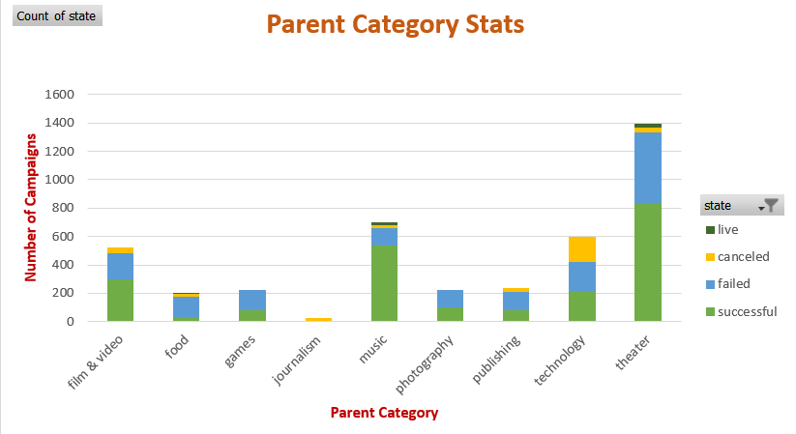

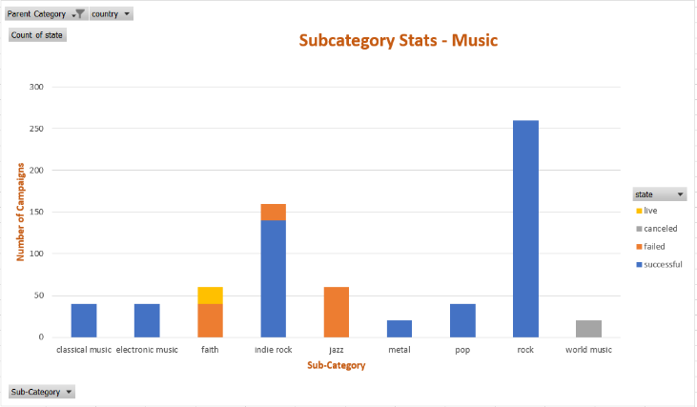 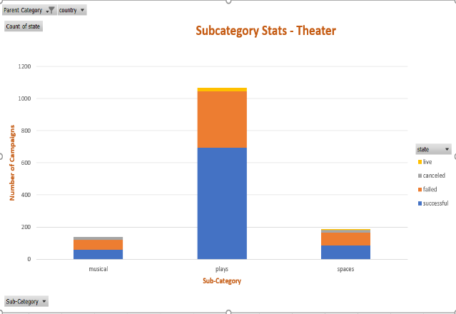

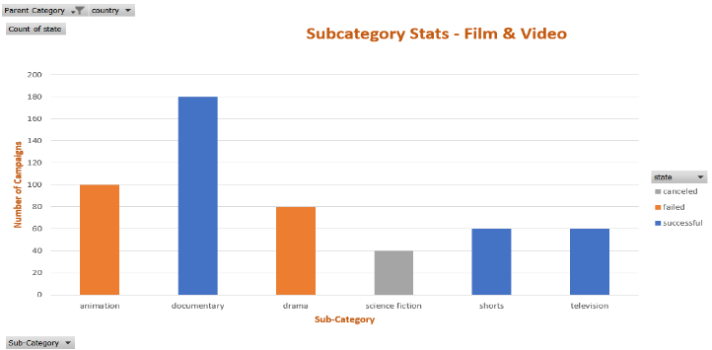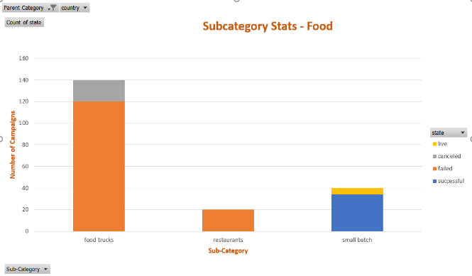

2. Another trend can be found is with respect to the goal that is set. Based on the data, lesser the goal amount, more successful are the campaigns.

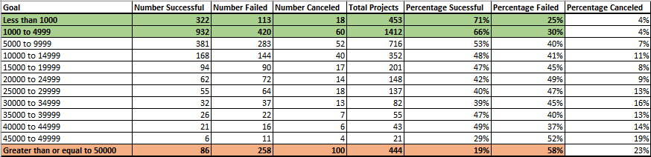

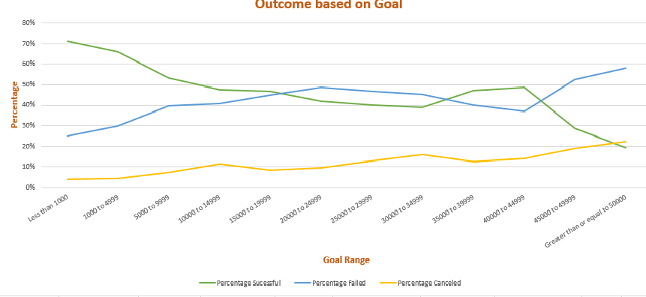

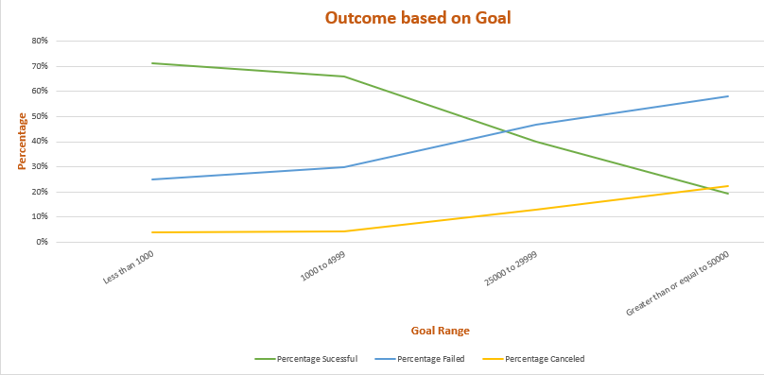

The percentage of success is dependent on the goal amount. The backers are more comfortable in funding the services with less goal. When the goal gets bigger, the likability to reach the target is highly unlikely. Therefore, whenever campaigners launch crowdfunding, if they could divide into several stages, that is into smaller achievable targets, successful outcomes become significant.

3. The trend can be found with respect to the month of launch too. As you can see, in the beginning of the year, rate of success is more significant as compared towards the end of the year.

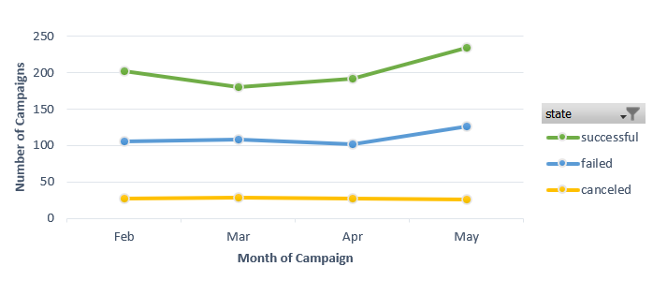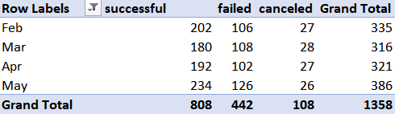

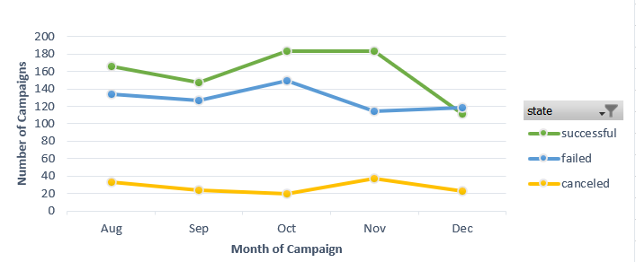

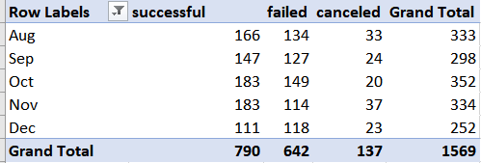

**Limitations of the dataset:**

* The dataset does not provide details about the actual investments or the special efforts put in by the campaigners to get more reachability and make backers comfortable to fund.
* If the campaigners are new to the platform or returning ones with history, will also help us analyze the trend.
* Is the current campaign similar to any other older campaigns? How successful is the older one? What are the shortcomings of the similar old campaigns? Based on this data, we could be able to make current campaign meet/exceed expectations of backers.

**Other possible table and/or graphs:**

1. The table can be created with the average amount funded per category. This will help us know the categories that are more successful with more comfortable backers.

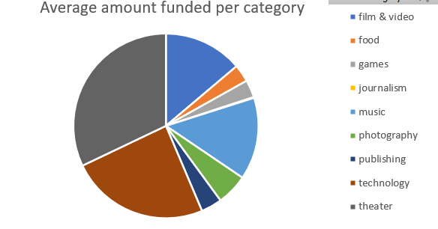

1. A Pivot table/chart can be created with count/average of backers on each category. This can summarize the interests of the backers towards the campaigns in various categories.

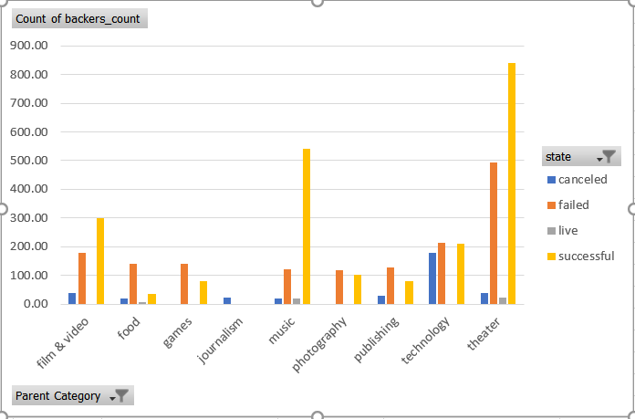

**Statistics summary:**

|  |  |  |  |  |  |  |
| --- | --- | --- | --- | --- | --- | --- |
| **STATISTICS SUMMARY BASED ON BACKERS COUNT** | | | | | | |
| **EVALUATION STATUS** | **Mean** | **Median** | **Minimum** | **Maximum** | **Variance** | **Standard Deviation** |
| **Successful Campaign** | 194.43 | 62 | 1 | 26,457 | 712840.99 | 844.30 |
| **Unsuccessful Campaign** | 17.71 | 4 | 0 | 1,293 | 3773.22 | 61.43 |

**Mean or Median:**

* The mean gets dragged away by few campaigns backed up by bigger count of backers, hence the Median summarizes the data more meaningfully.
* The below chart shows the distortion of backers count with respect to campaigns successful. Since the data is not normally distributed and has outliers, it would be more appropriate to use Median to summarize the central tendency of the data.

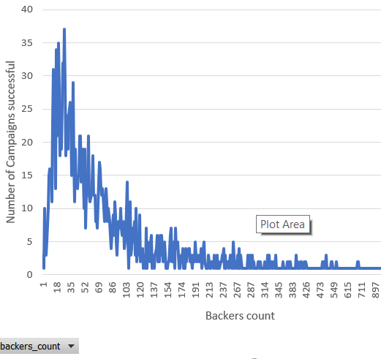

**Variability with campaigns:**

The Variance with successful campaigns is 712840.99 whereas the variability with unsuccessful campaign is 3773.22. This shows, there **is more variability with the successful campaigns**. There are as minimum as 1 backer and maximum of 26,457 backers under successful campaigns which makes the outliers dragging away from the central tendency of the data.